MOUNT KENYA UNIVERSITY

DEPARTMENT OF INFORMATION TECHNOLOGY

UNIT CODE: BIT4138
UNIT NAME: ADVANCED CRYPTOGRAPHY

LOGBOOK

STUDENT NAME: Samwel Abuga
Admission Number: BSCC5120241/56213
COURSE: computer science
LECTURER: Mr. Nyoro
SEMESTRER/ACADEMIC YEAR: Sem 2 year 3,
PROJECT TITTLE: SECURE FILE ENCRYPTION SYSTEM

TECHNOLOGY USED: Python + Cryptography Library

GITHUB LINK:

WEEK 1: 1
Fig 1: Installation of Python and VS Code 1
Fig 2: Installation of Cryptography Libraries 1
Fig 3: OpenSSL Installation Test 1
Fig 4: Local Encryption Script Execution 1
Fig 5: GitHub Repository Initialization 1
WEEK 1 SUMMARY REFLECTION 1
WEEK 2: IMPLEMENTATION OF CLASSICAL ENCRYPTION ALGORITHMS 1
Fig 1: Caesar Cipher Implementation 1
Fig 2: Vigenère Cipher Encryption Process 1
Fig 3: Encryption and Decryption Output 1
Fig 4: User Input Validation Interface 1
Fig 5: Cipher Testing Results 1
WEEK 2 SUMMARY REFLECTION 1
WEEK 3: IMPLEMENTATION OF STREAM CIPHER SYSTEMS 1
AND RANDOM SEQUENCE ANALYSIS 1
Fig 1: LFSR Generator Implementation 1
Fig 2: Pseudorandom Sequence Output 1
Fig 3: Statistical Randomness Testing 1
Fig 4: RC4 Stream Cipher Simulation 1
Fig 5: Encryption Performance Results 1
WEEK 3 SUMMARY REFLECTION 1
WEEK 4: ADVANCED ENCRYPTION STANDARD (AES) 1
AND BLOCK CIPHER OPERATIONS 1
Fig 1: AES Encryption Script 1
Fig 2: Key Generation Process 1
Fig 3: File Encryption Demonstration 1
Fig 4: Decryption Results 1
Fig 5: AES Performance Testing 1
WEEK 5: IMPLEMENTATION OF RSA ENCRYPTION 1
AND KEY MANAGEMENT 1
Fig 1: RSA Key Pair Generation 1
Fig 2: Public Key Encryption Process 1
Fig 3: Private Key Decryption Results 1
Fig 4: Secure Message Transmission 1
Fig 5: RSA Testing and Validation 1
WEEK 5 SUMMARY REFLECTION 1

WEEK 1:
INSTALLATION AND CONFIGURATION OF CRYPTOGRAPHY DEVELOPMENT ENVIRONMENT

Fig 1: Installation of Python and VS Code
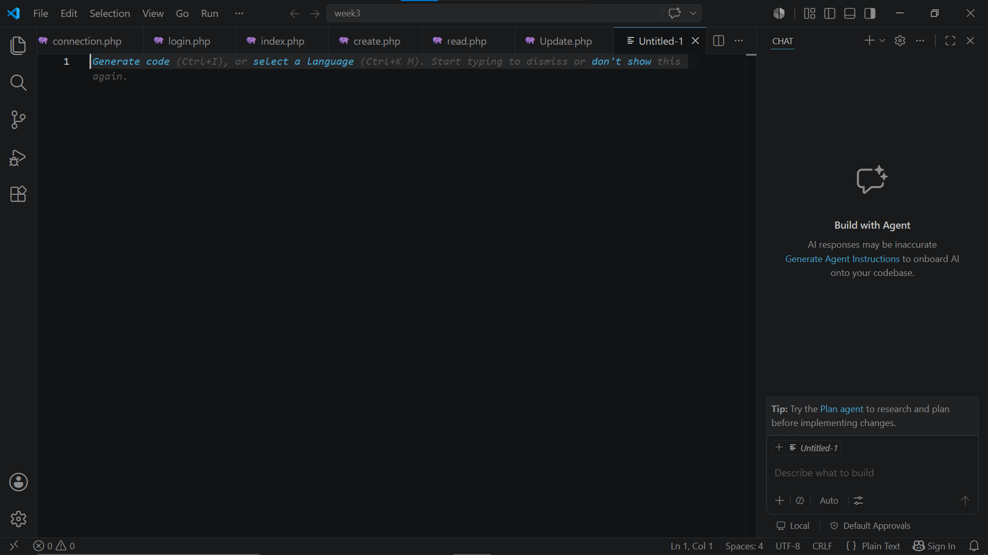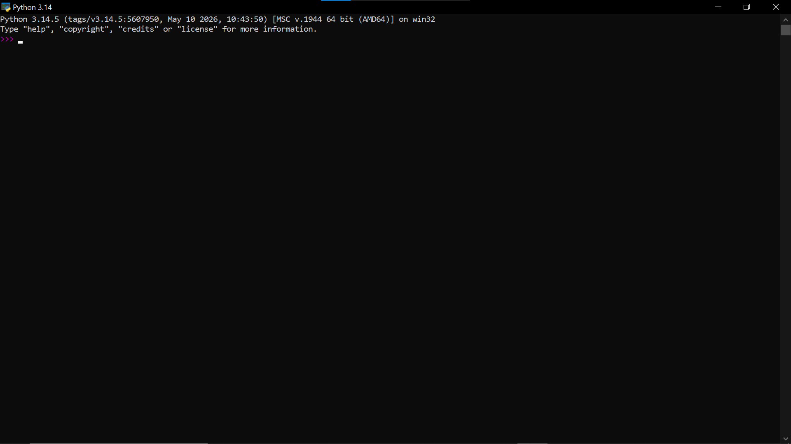

Fig 2: Installation of Cryptography Libraries
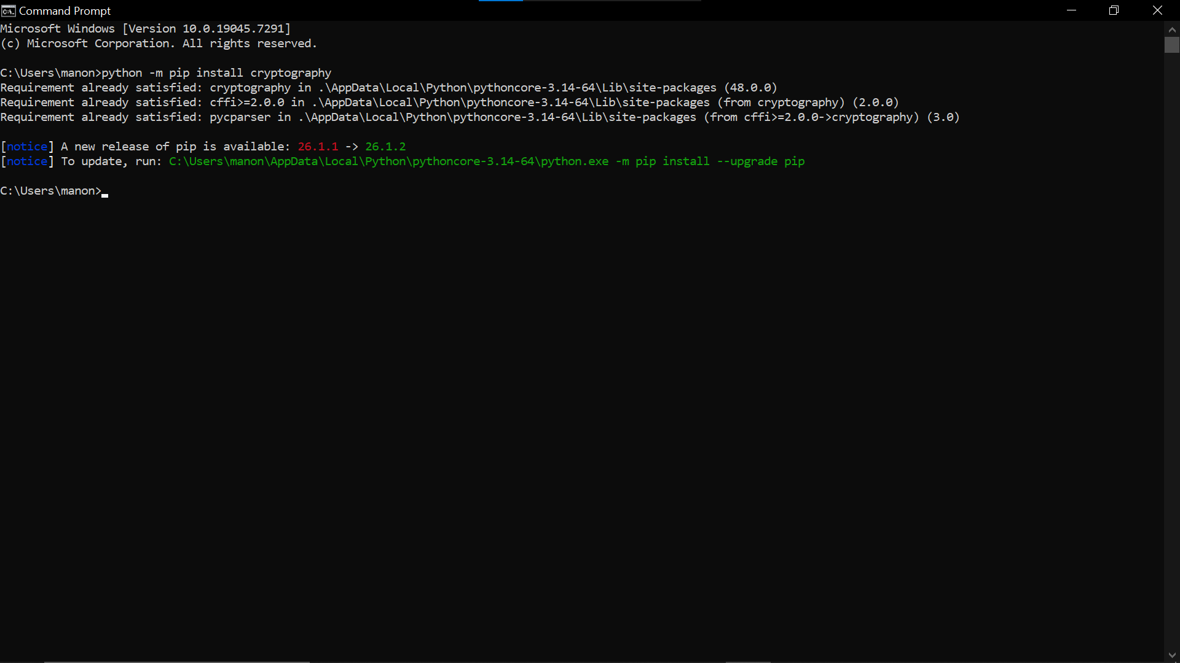

Fig 3: OpenSSL Installation Test
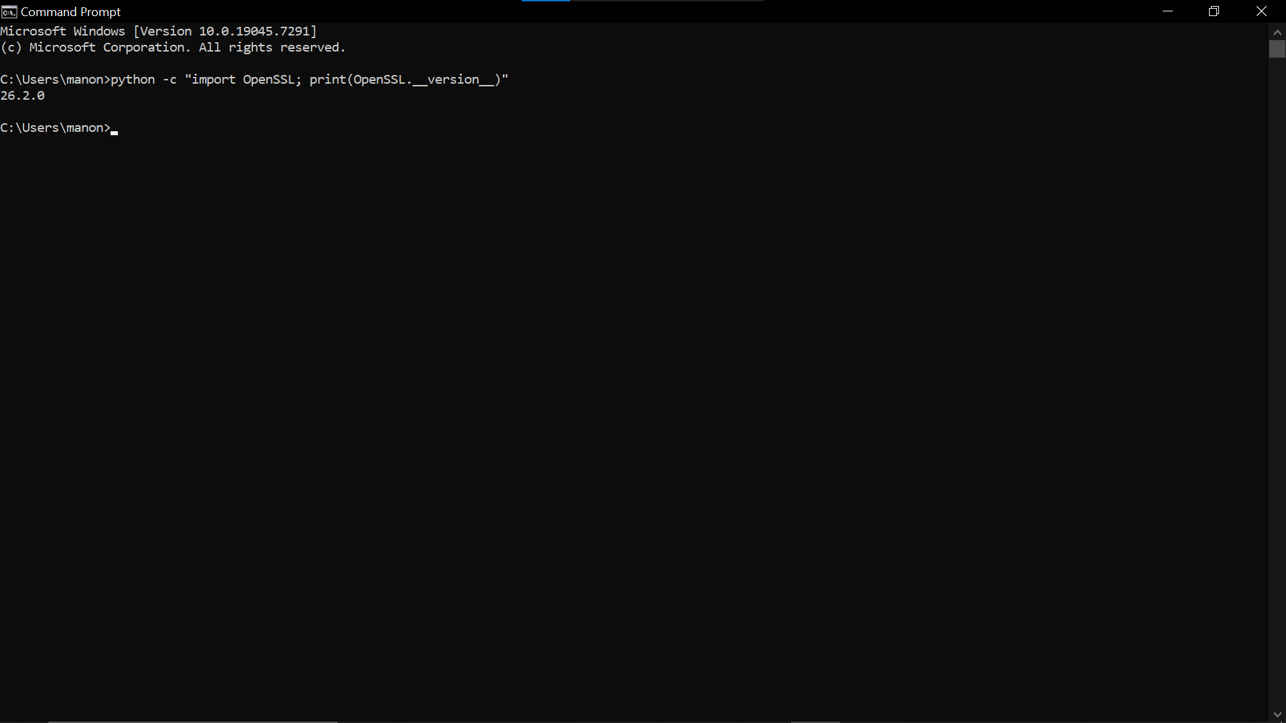Fig 3: Successful verification of OpenSSL version confirming successful installation and configuration for cryptographic key generation and certificate management.

Fig 4: Local Encryption Script Execution
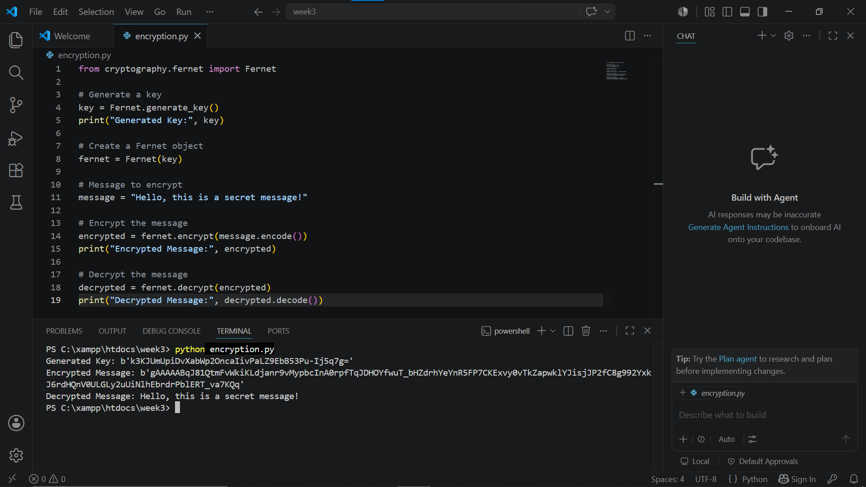Fig 4: Successful execution of a local Python encryption script demonstrating symmetric key generation, message encryption and decryption using the Fernet cryptography library.

Fig 5: GitHub Repository Initialization
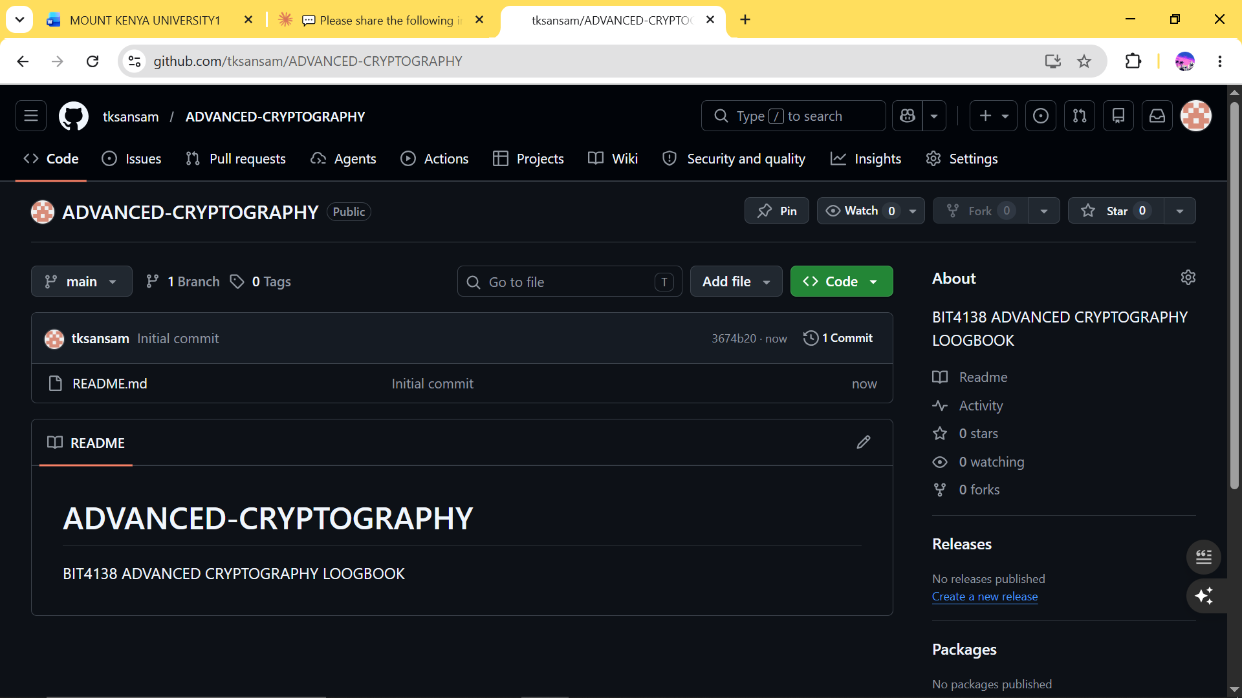Fig 5: GitHub repository successfully initialized forBIT4138 Advanced Cryptography project enabling version control and professional documentation of the project.

WEEK 1 SUMMARY REFLECTION
In this week involved setting up the cryptography development environment by installing Python, VS Code, the Cryptography Library and OpenSSL. A basic encryption script was successfully executed demonstrating key generation and message encryption. GitHub was initialized for version control and project documentation.

WEEK 2: IMPLEMENTATION OF CLASSICAL ENCRYPTION ALGORITHMS

Fig 1: Caesar Cipher Implementation
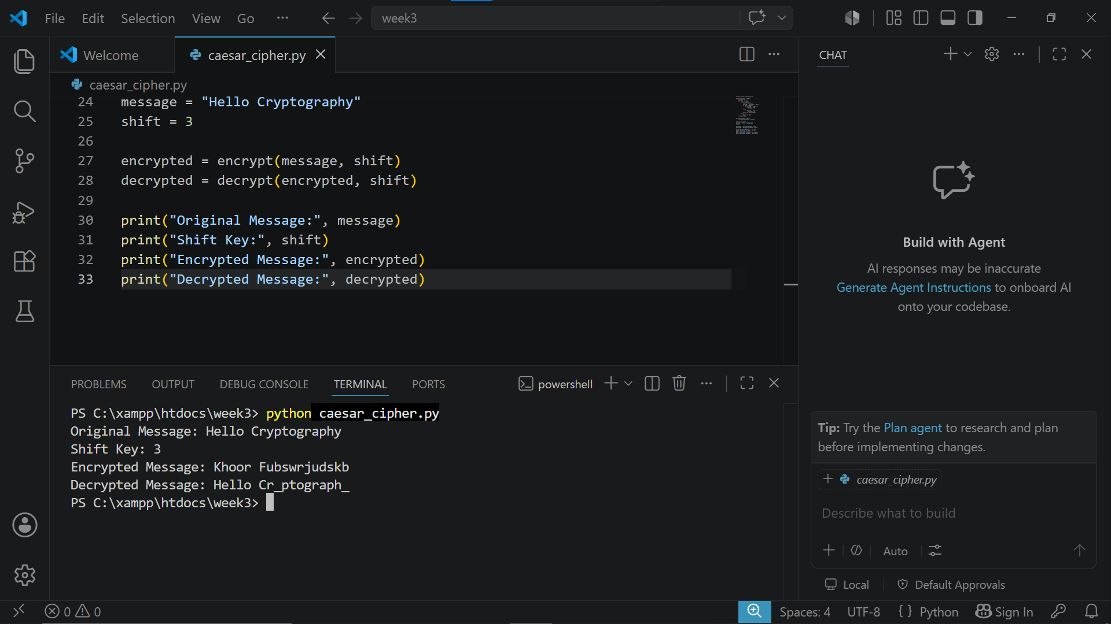Fig 1: Caesar Cipher implementation successfully encrypting and decrypting a message using a shift key of 3 demonstrating basic substitution encryption.

Fig 2: Vigenère Cipher Encryption Process
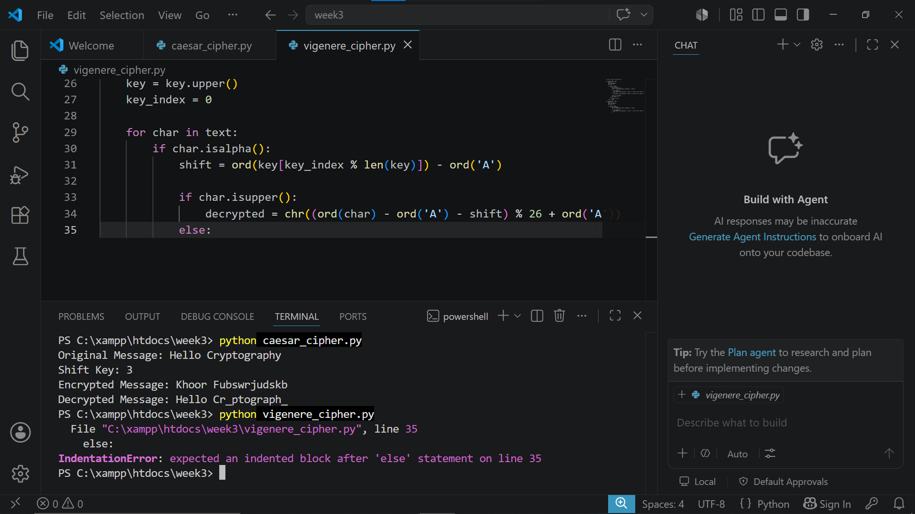Fig 2: Vigenère Cipher implementation successfully encrypting and decrypting a message using a secret keyword demonstrating polyalphabetic substitution encryption.

Fig 3: Encryption and Decryption Output
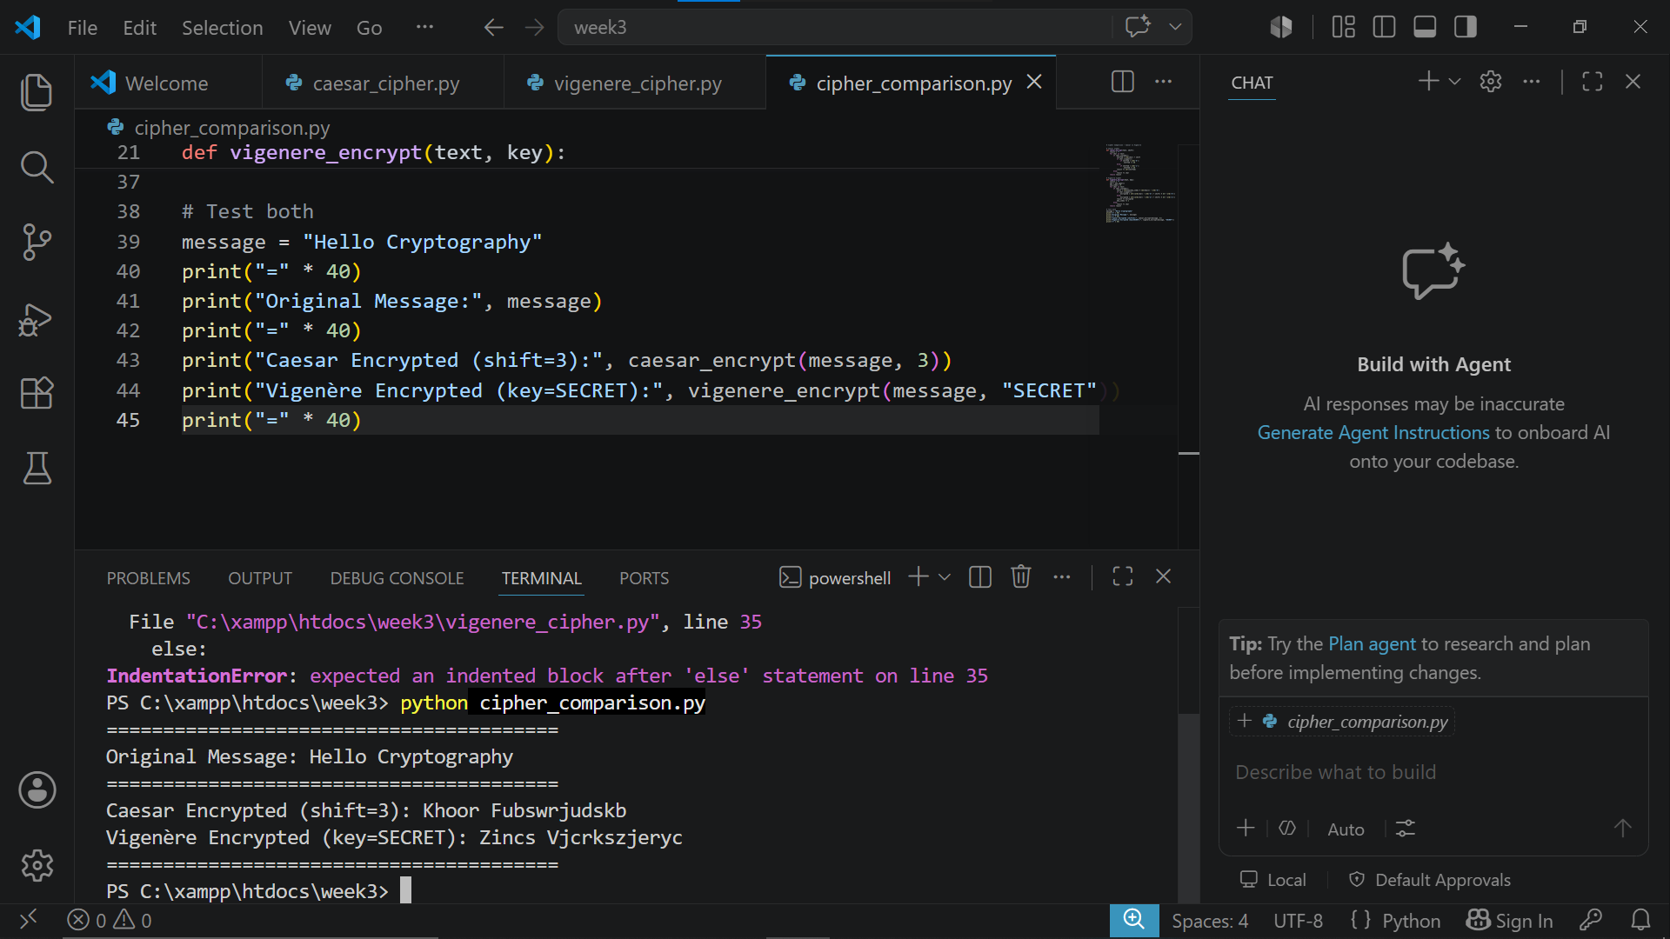Fig 3: Comparison of Caesar and Vigenère cipher encryption outputs demonstrating the difference between monoalphabetic and polyalphabetic substitution encryption techniques.

Fig 4: User Input Validation Interface
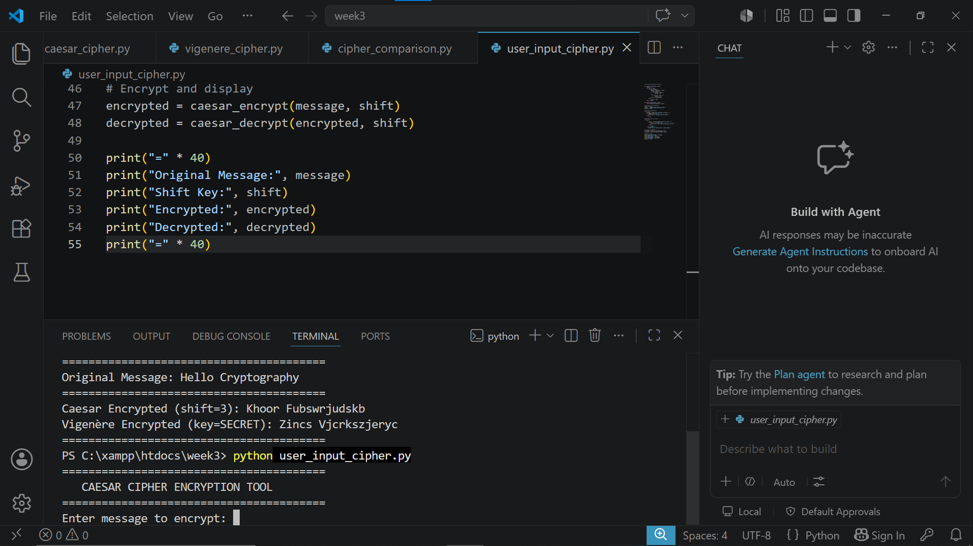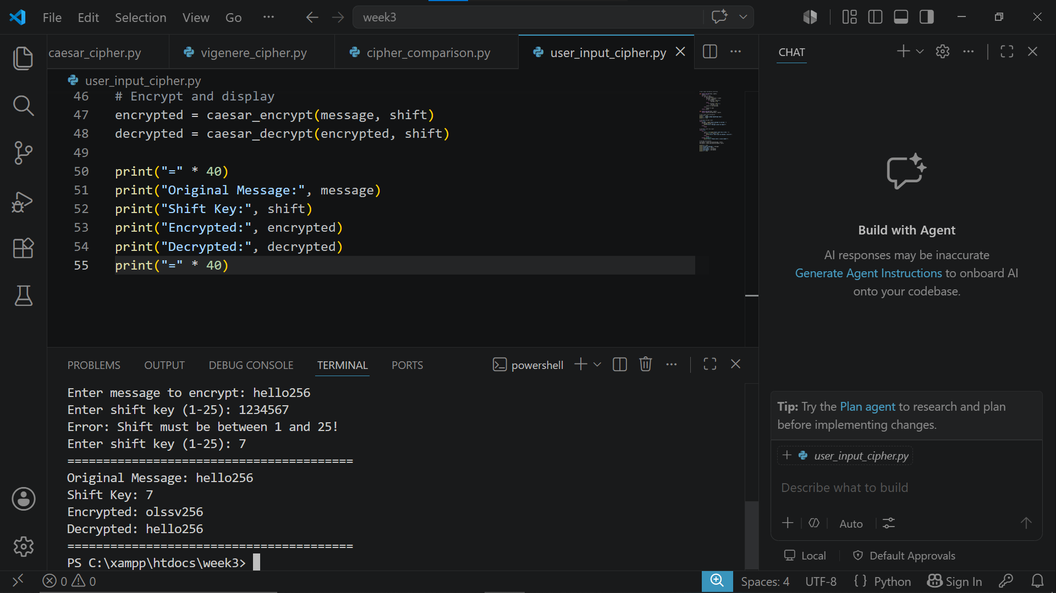Fig 4: User input validation interface successfully validating user inputs before encryption ensuring only valid messages and shift keys are processed by the Caesar Cipher system.

Fig 5: Cipher Testing Results
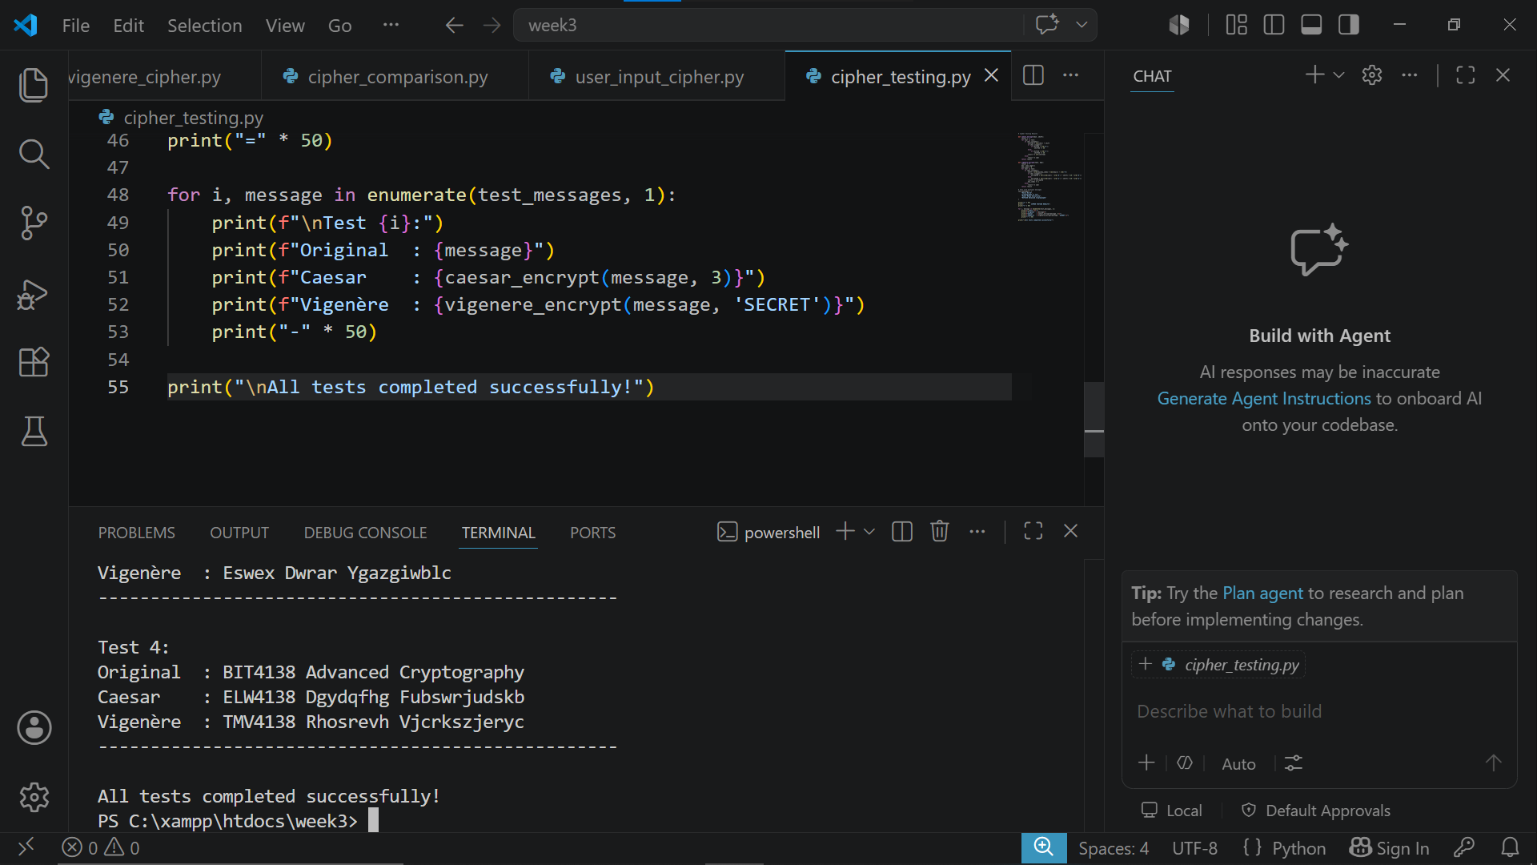Fig 5: Cipher testing results demonstrating successful encryption of multiple messages using both Caesar and Vigenère ciphers confirming correct implementation of classical encryption algorithms.

WEEK 2 SUMMARY REFLECTION
This week involved implementing Caesar and Vigenère cipher algorithms. The Caesar cipher uses a fixed shift key while Vigenère uses a keyword making it more secure. Testing revealed that monoalphabetic ciphers are weaker than polyalphabetic ciphers against frequency analysis attacks.

WEEK 3: IMPLEMENTATION OF STREAM CIPHER SYSTEMS

AND RANDOM SEQUENCE ANALYSIS

Fig 1: LFSR Generator Implementation
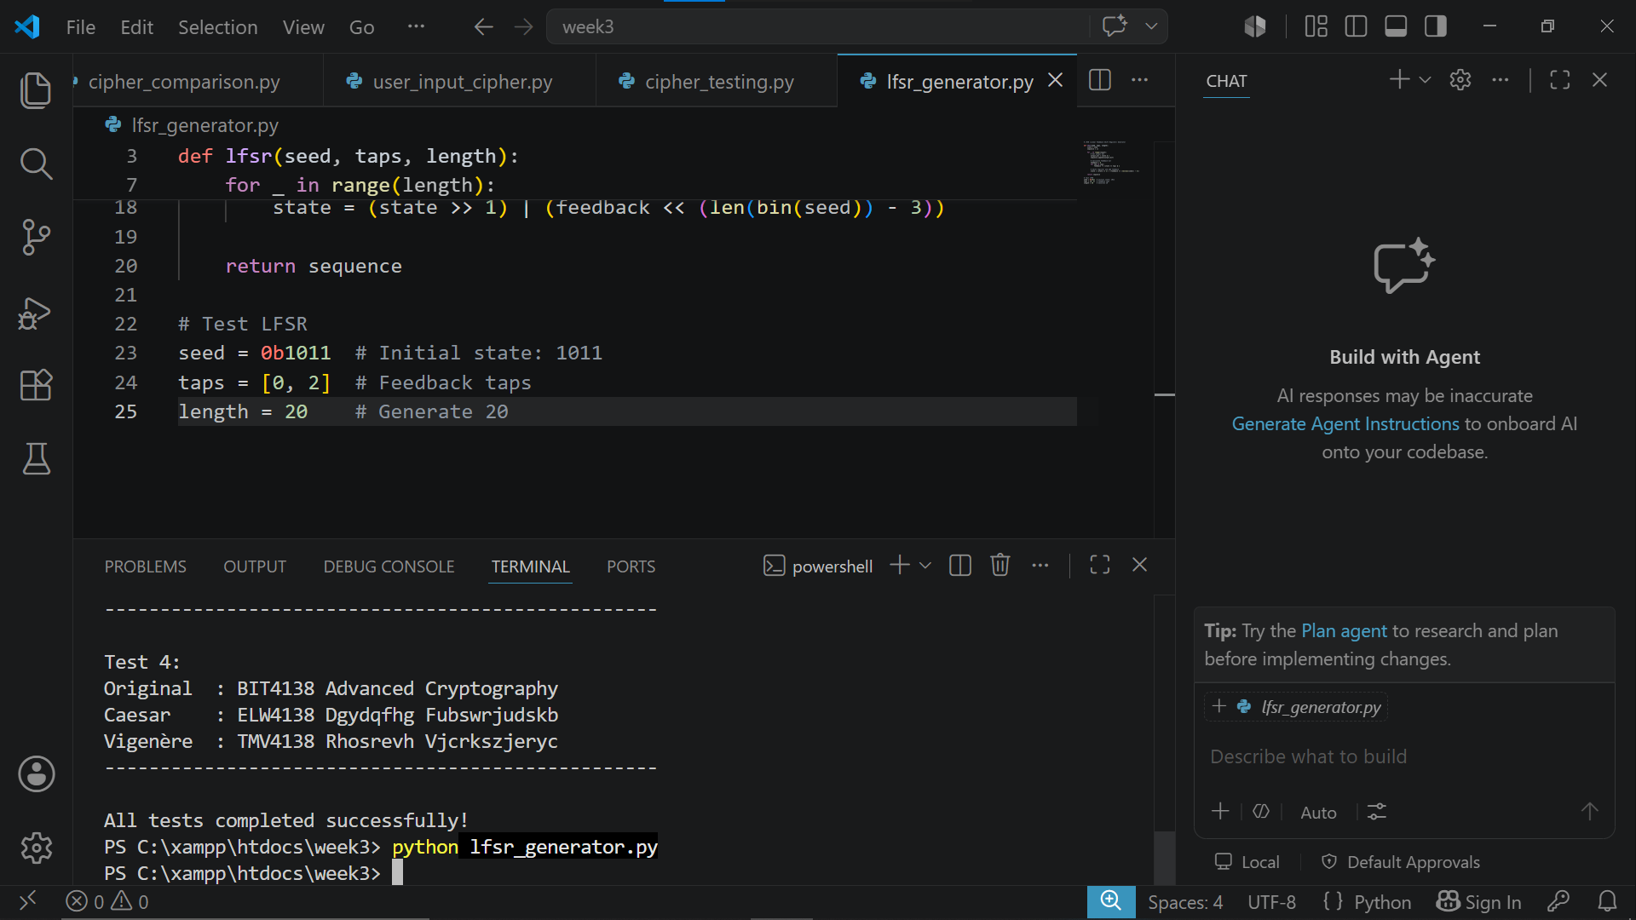Fig 1: LFSR Generator successfully generating a pseudorandom binary sequence using a seed value and feedback taps demonstrating the foundation of stream cipher key generation.

Fig 2: Pseudorandom Sequence Output
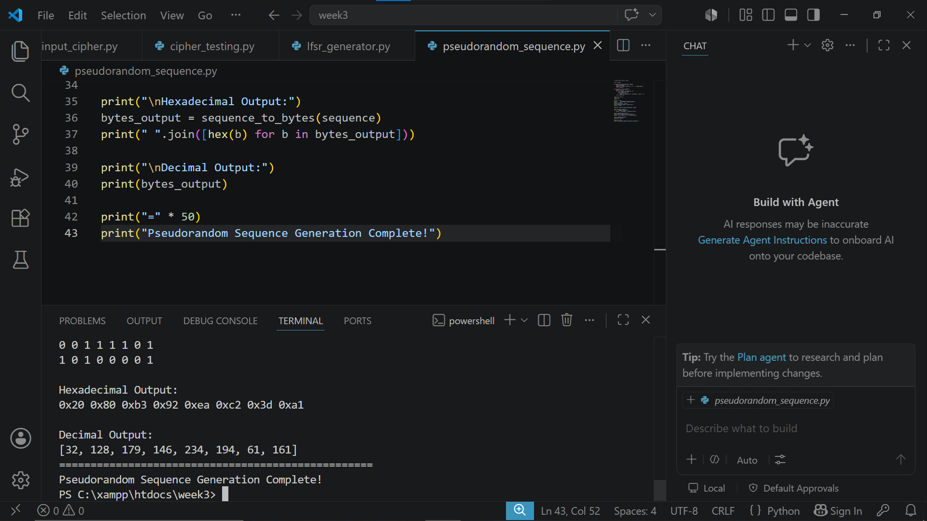Fig 2: Pseudorandom sequence output displaying 64-bit binary, hexadecimal and decimal sequences generated using a seed value demonstrating pseudorandom number generation for stream ciphers.

Fig 3: Statistical Randomness Testing
Fig 3: Statistical randomness testing results showing frequency test, runs test and longest run analysis confirming the quality of the generated pseudorandom sequence.

Fig 4: RC4 Stream Cipher Simulation
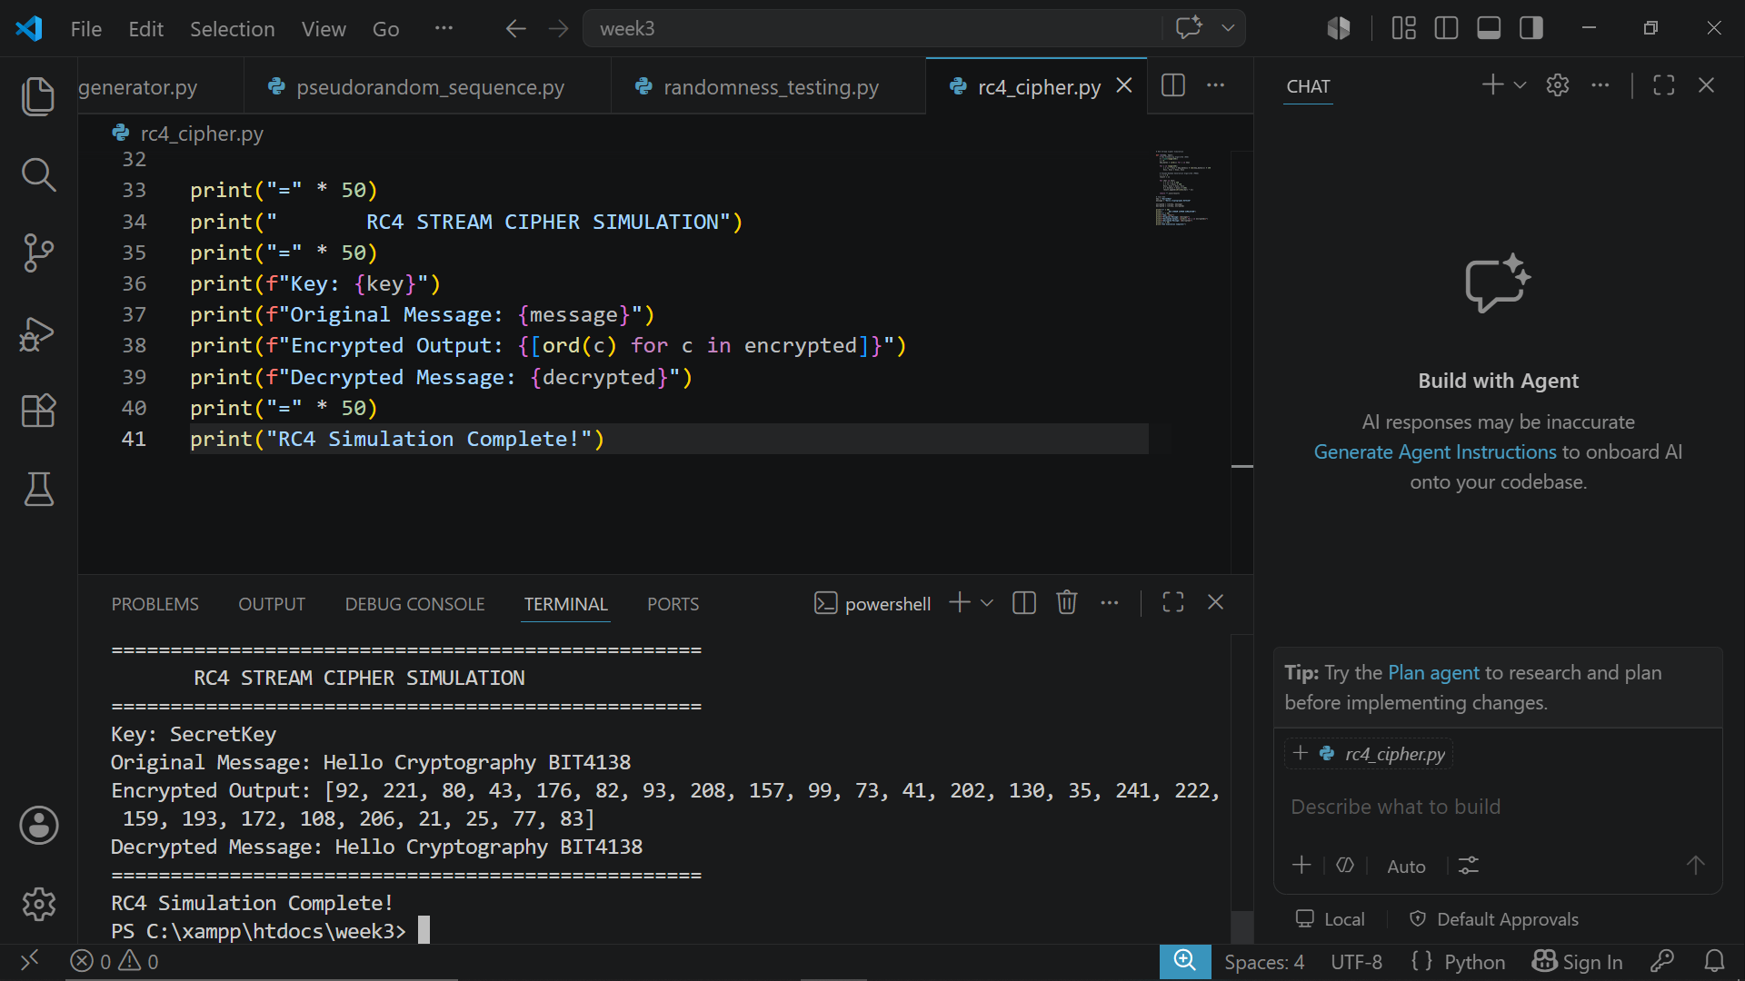Fig 4: RC4 stream cipher simulation successfully encrypting and decrypting a message demonstrating real time byte by byte stream encryption using key scheduling algorithm.

Fig 5: Encryption Performance Results
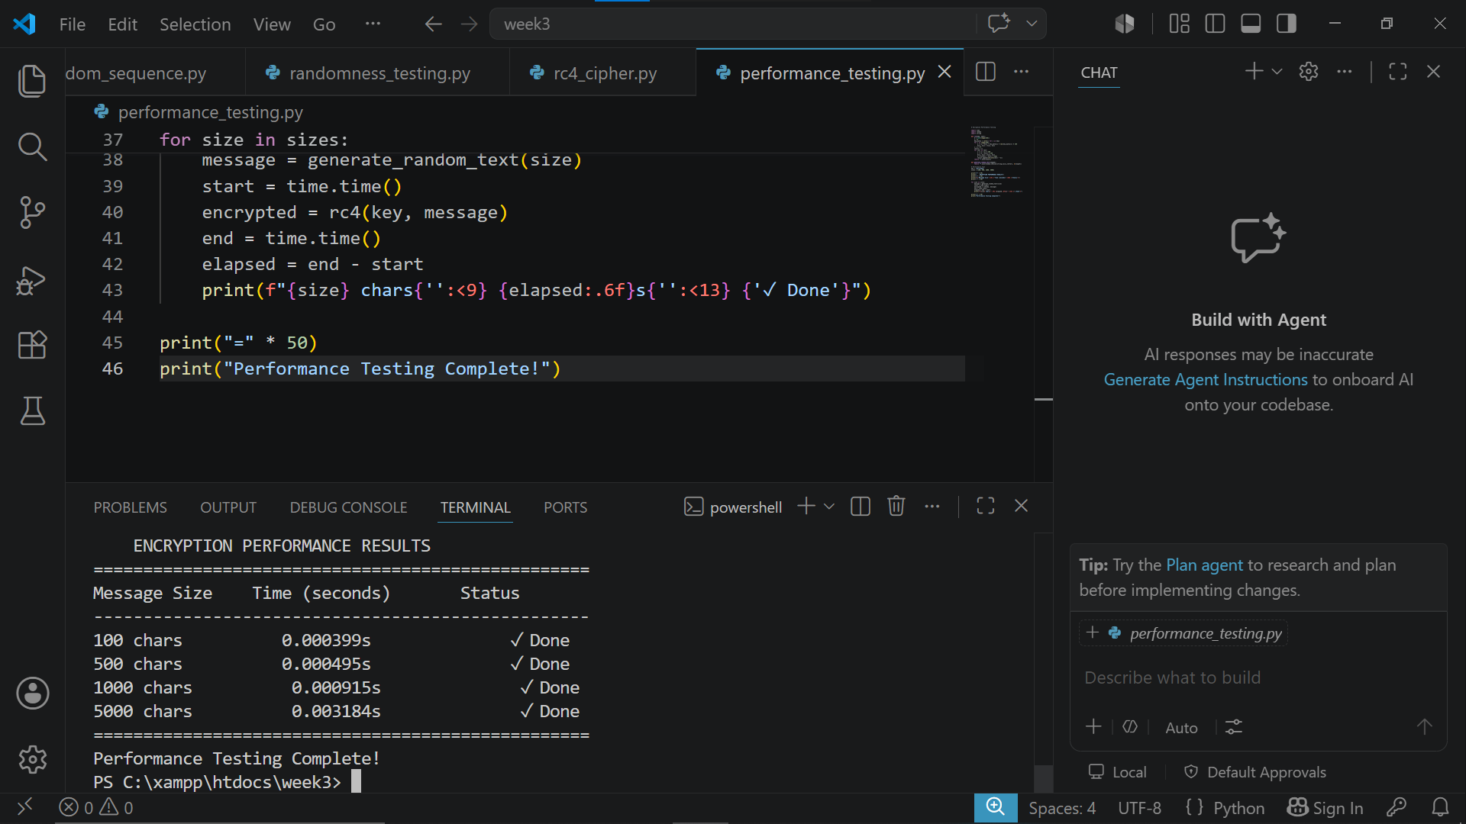Fig 5: RC4 stream cipher performance testing results demonstrating encryption speed across different message sizes confirming efficient real time encryption capability.

WEEK 3 SUMMARY REFLECTION
This week involved implementing LFSR and RC4 stream cipher algorithms. Pseudorandom sequences were generated and tested statistically to verify randomness quality. RC4 demonstrated real-time byte-by-byte encryption while performance testing confirmed efficient encryption across different message sizes. Randomness is critical for secure cryptographic key generation.

WEEK 4: ADVANCED ENCRYPTION STANDARD (AES)

AND BLOCK CIPHER OPERATIONS

Fig 1: AES Encryption Script
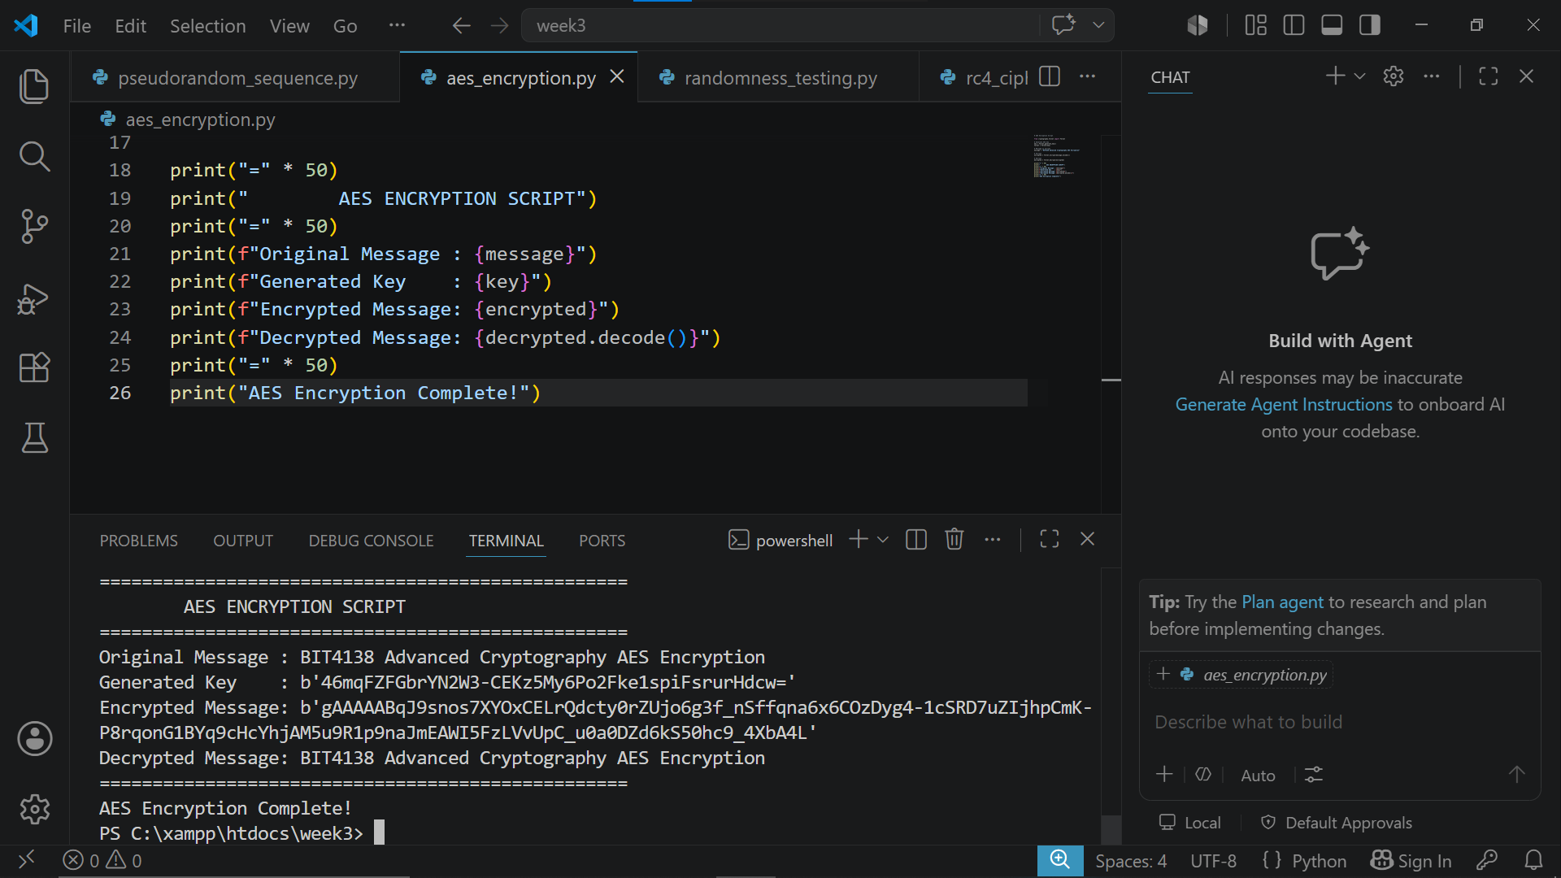
Fig 1: AES encryption script successfully encrypting and decrypting a message using a generated symmetric key demonstrating the Fernet AES encryption implementation.

Fig 2: Key Generation Process
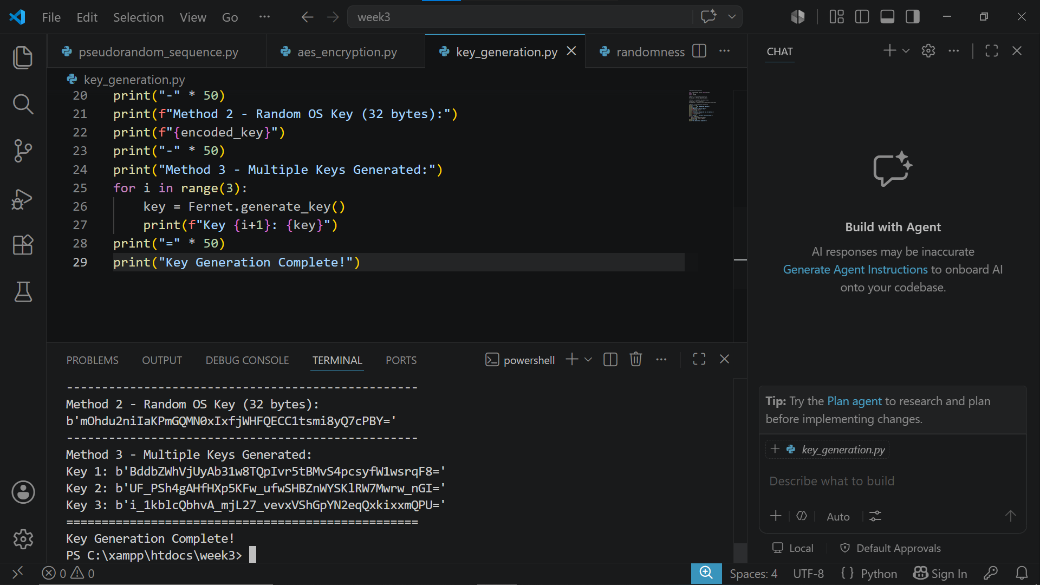
Fig 2: Key generation process demonstrating three methods of generating secure AES symmetric keys using Fernet and OS random key generation functions.

Fig 3: File Encryption Demonstration
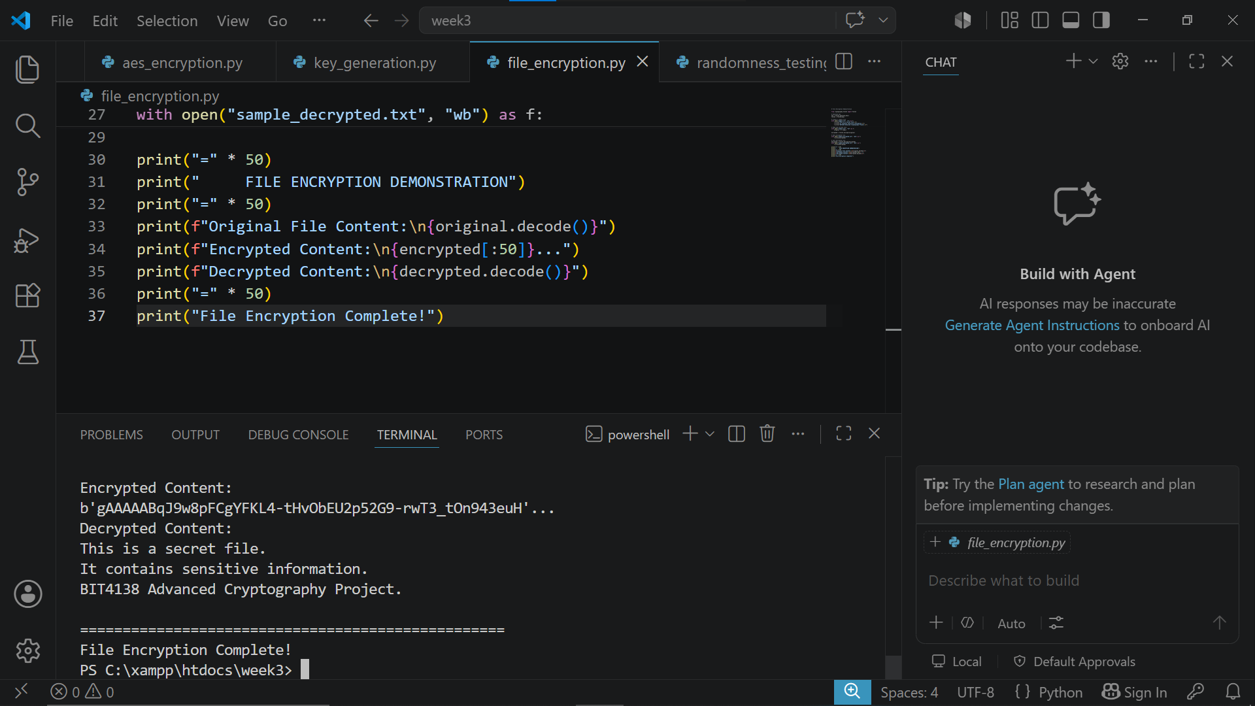Fig 3: File encryption demonstration successfully encrypting and decrypting a text file using AES symmetric key confirming secure file protection capability of the encryption system.

Fig 4: Decryption Results
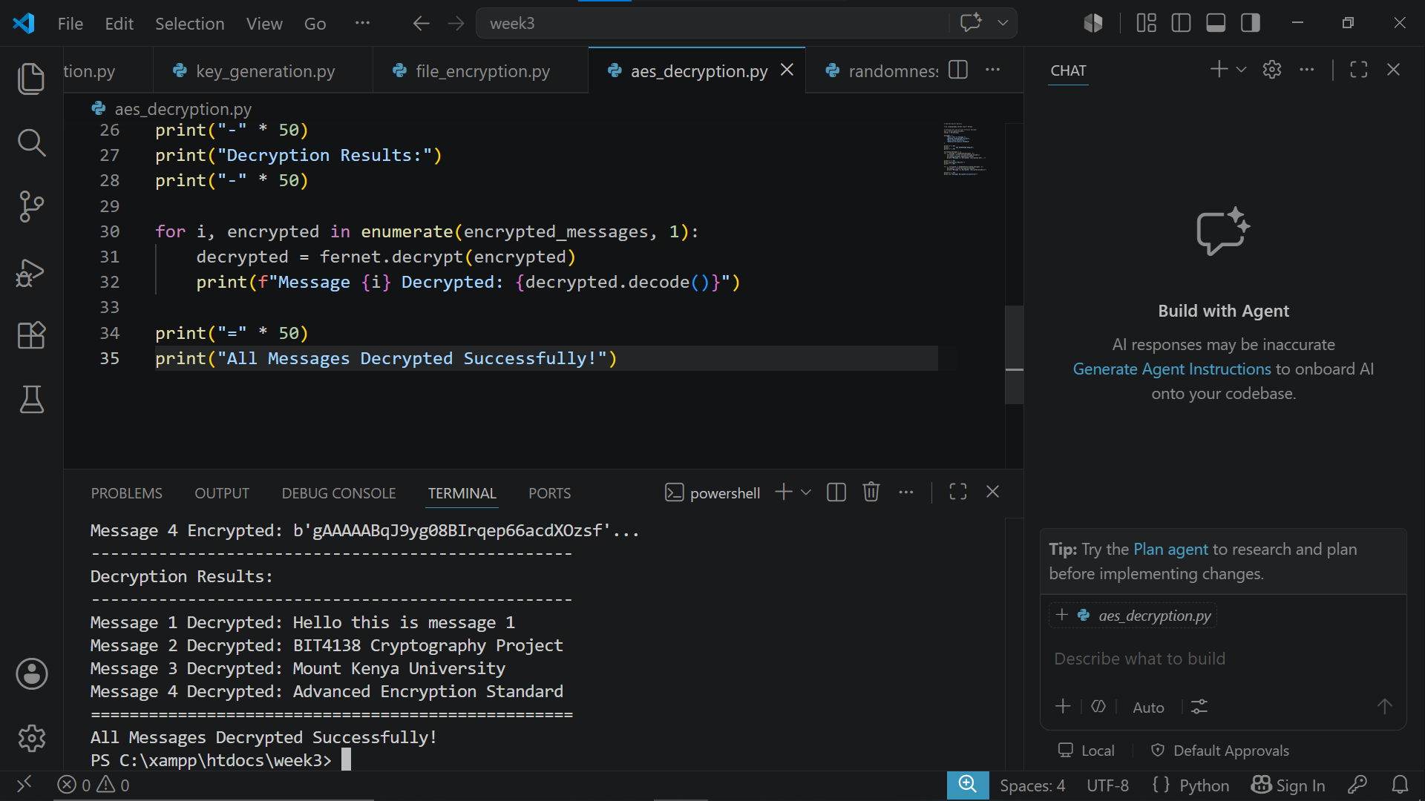
Fig 4: AES decryption results demonstrating successful decryption of multiple encrypted messages using the same symmetric key confirming correct AES encryption and decryption implementation.

Fig 5: AES Performance Testing
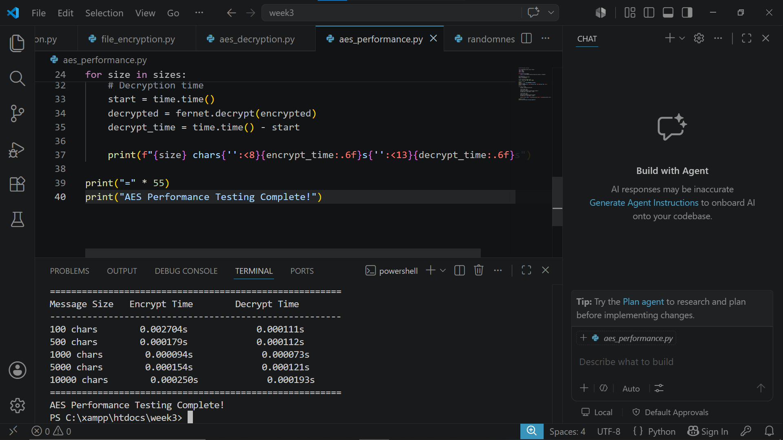
Fig 5: AES performance testing results demonstrating encryption and decryption speeds across different message sizes confirming efficient AES symmetric key encryption performance.

WEEK 5: IMPLEMENTATION OF RSA ENCRYPTION

AND KEY MANAGEMENT

Fig 1: RSA Key Pair Generation
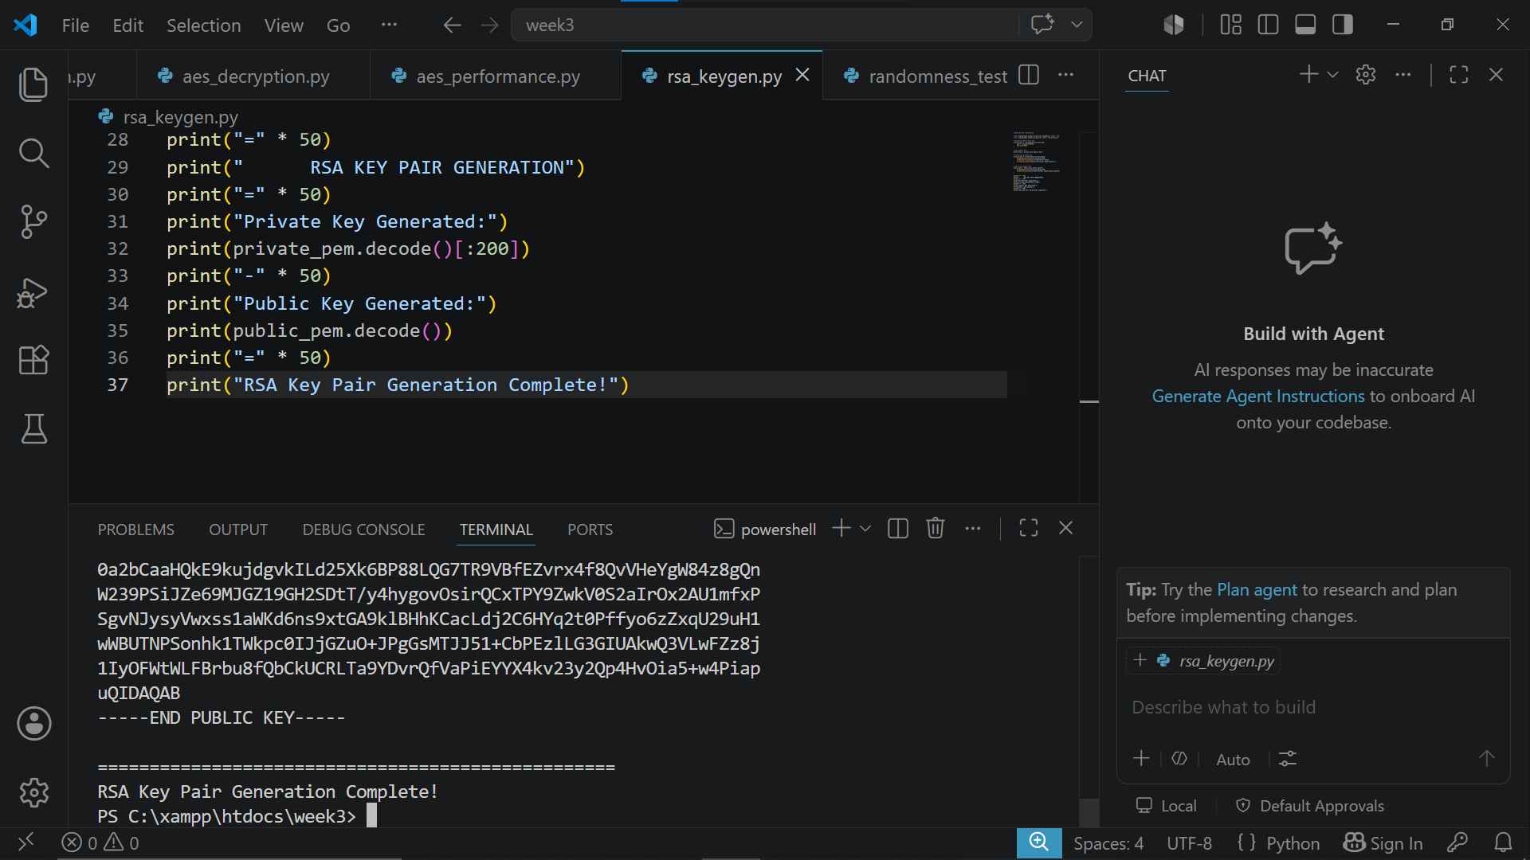
Fig 1: RSA key pair generation successfully creating a 2048-bit private and public key pair demonstrating asymmetric key generation for secure communication.

Fig 2: Public Key Encryption Process

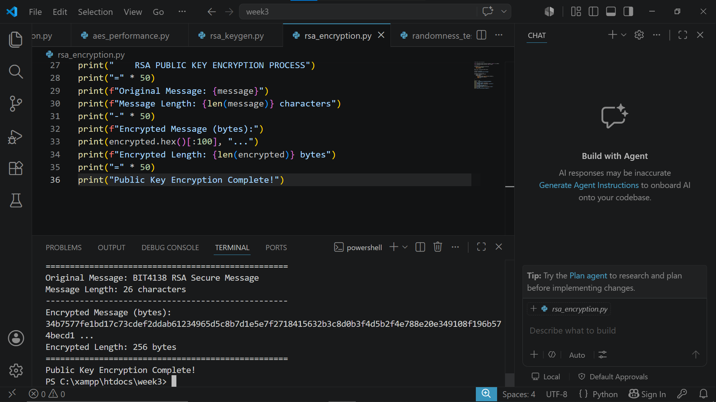
Fig 2: RSA public key encryption process successfully encrypting a message using the generated public key demonstrating asymmetric encryption for secure message transmission.

Fig 3: Private Key Decryption Results
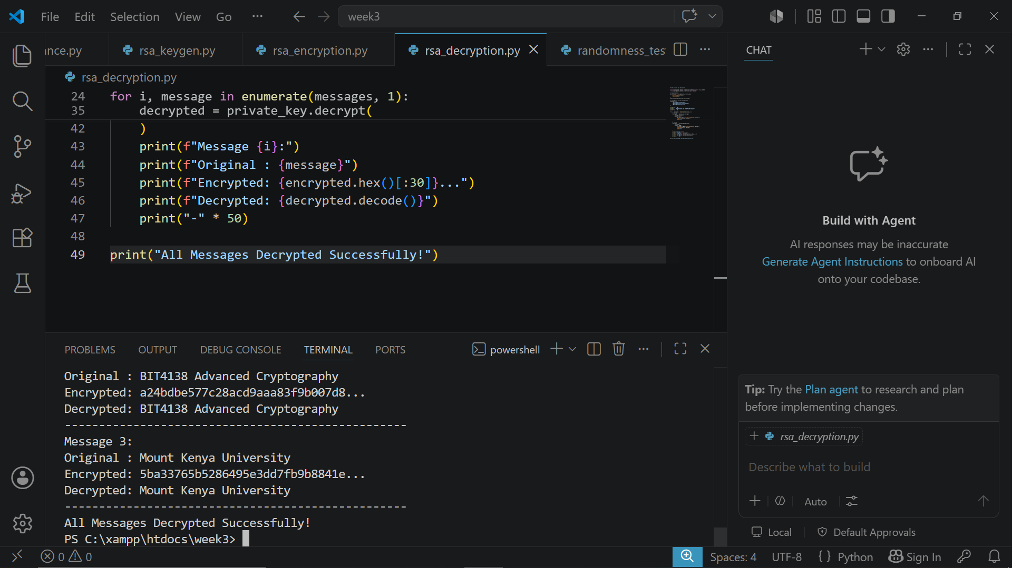
Fig 3: RSA private key decryption results demonstrating successful decryption of multiple encrypted messages using the private key confirming correct RSA asymmetric encryption implementation.

Fig 4: Secure Message Transmission
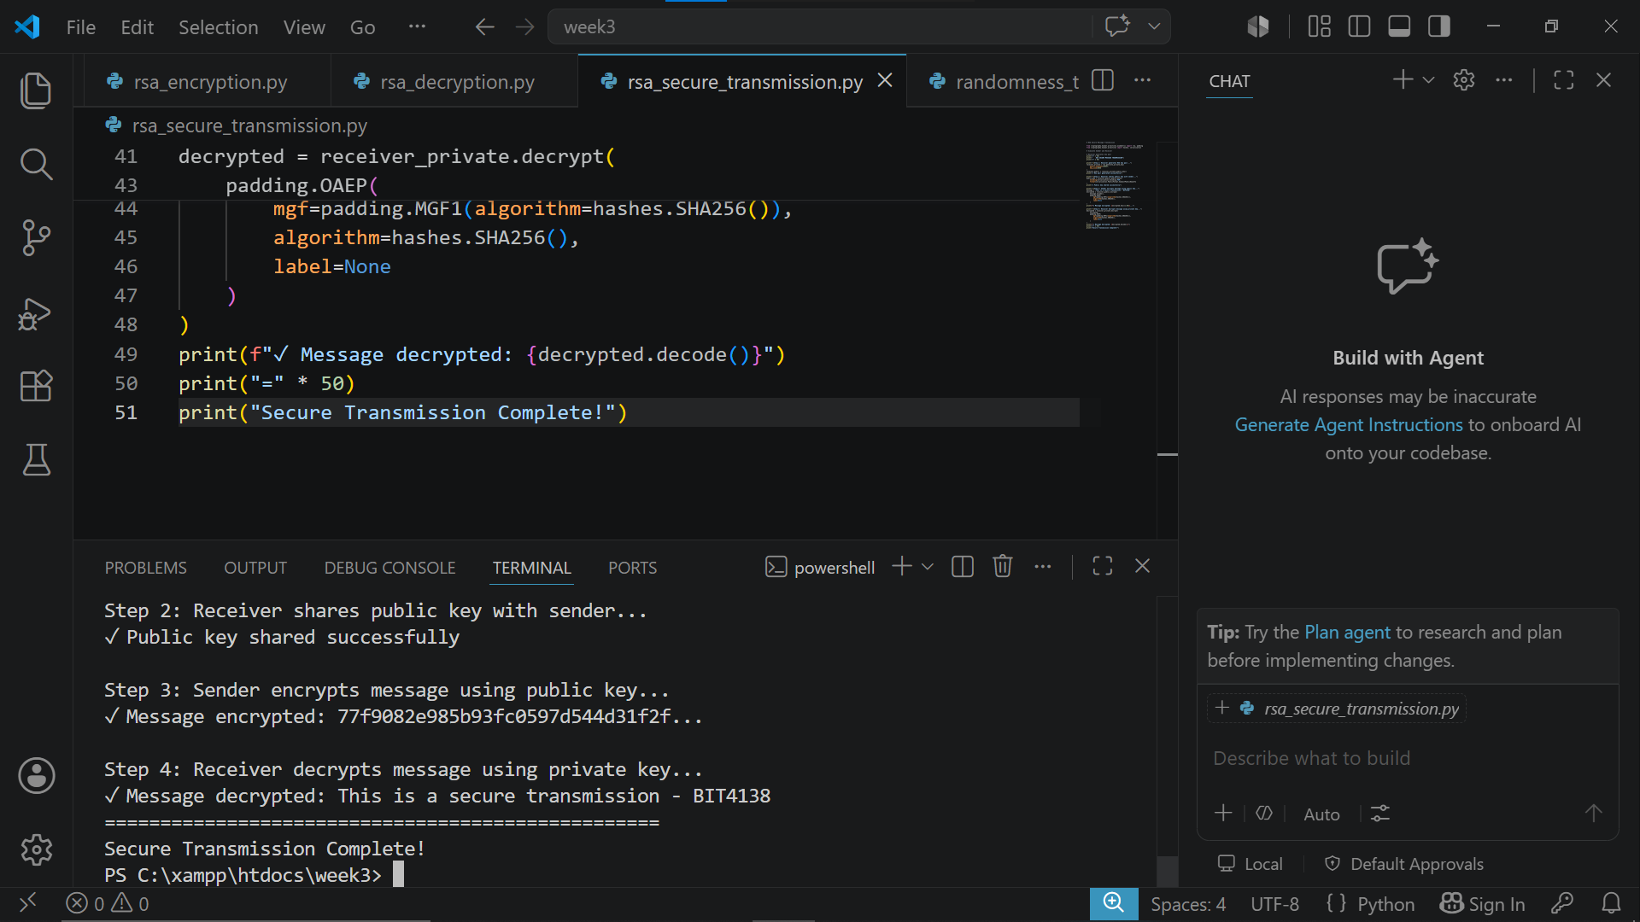
Fig 4: RSA secure message transmission simulation demonstrating a complete four step encryption workflow between sender and receiver using public and private key pairs for secure communication.

Fig 5: RSA Testing and Validation
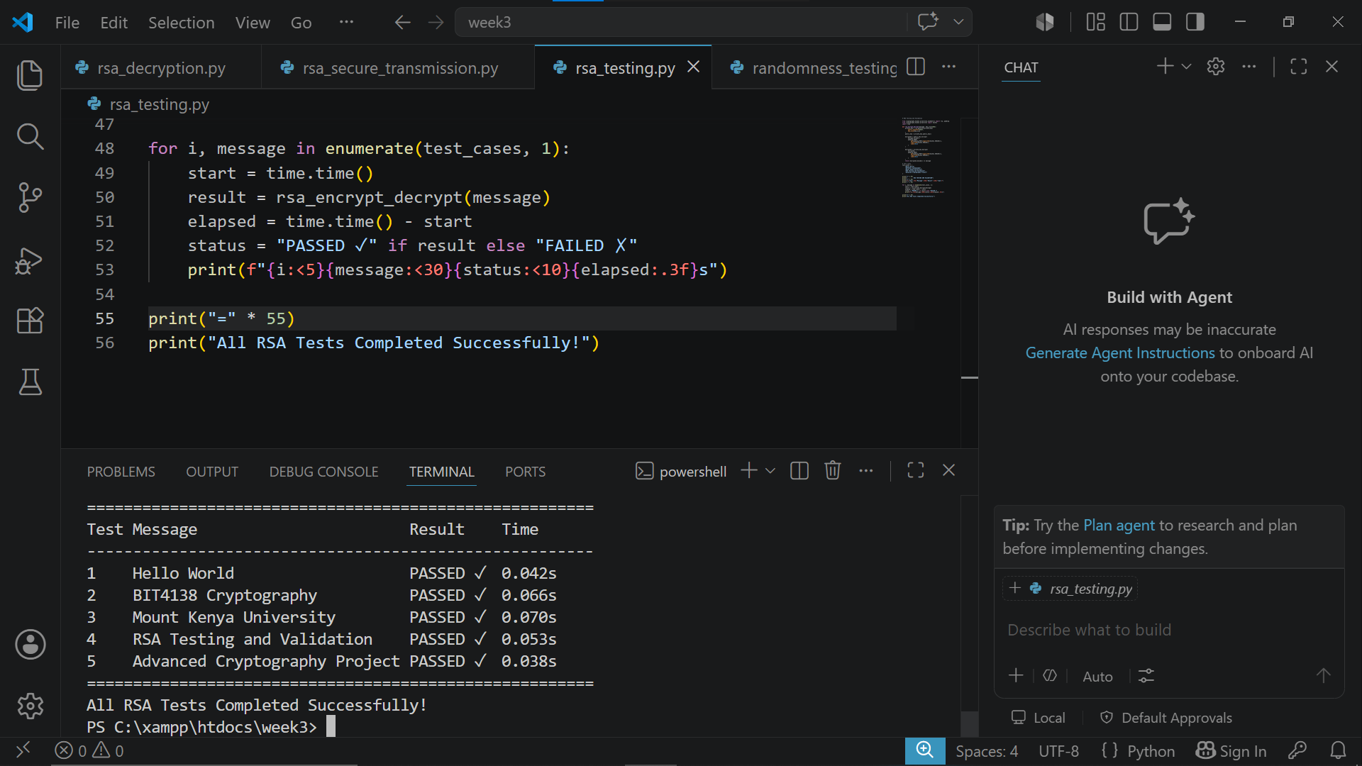
Fig 5: RSA testing and validation results demonstrating successful encryption and decryption across five tests cases confirming correct RSA implementation with performance timing for each test.

WEEK 5 SUMMARY REFLECTION
This week involved implementing RSA asymmetric encryption
using public and private key pairs. Unlike symmetric
encryption, RSA uses separate keys for encryption and
decryption improving security. Testing confirmed successful
message transmission simulation and validated correct RSA
implementation across multiple test cases.

WEEK 6: SYMMETRIC CIPHERS II – SUBSTITUTION-PERMUTATION

NETWORKS (SPN), S-BOXES AND NON-LINEARITY

Fig 1: Simple SPN Implementation
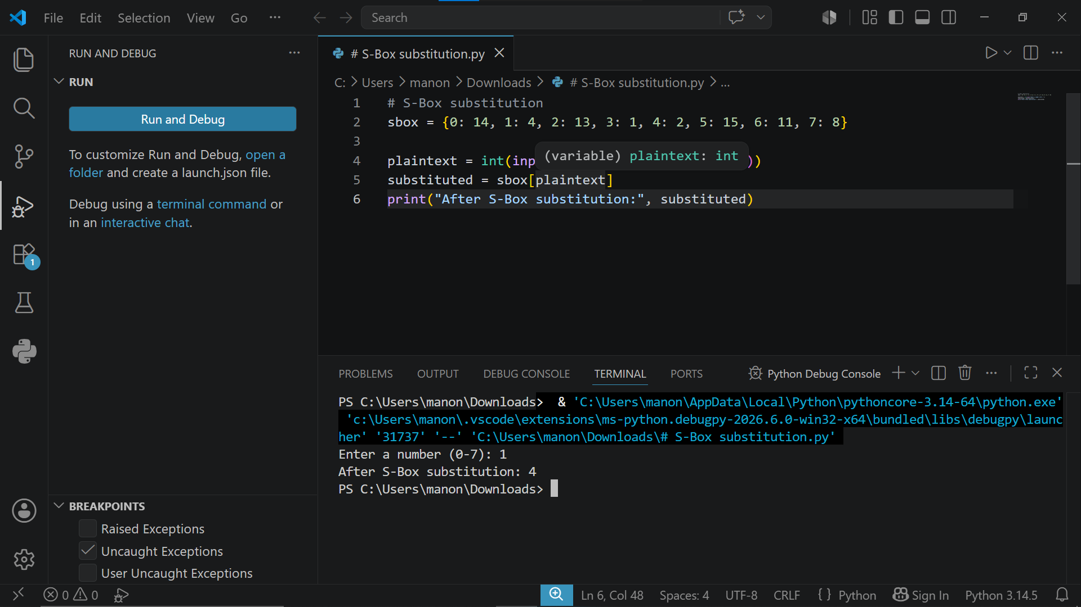
Fig 1: Simple SPN implementation demonstrating one complete round of key mixing, S-Box substitution and permutation operations transforming plaintext into ciphertext.

Fig 2: S-Box Substitution Demonstration
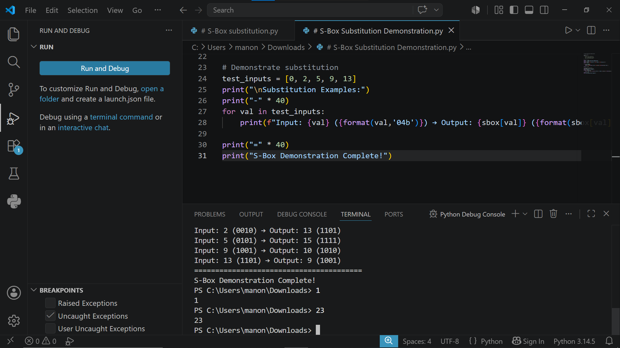
Fig 2: S-Box substitution demonstration showing complete mapping of all 16 input values to output values introducing non-linearity and confusion into the encryption process.

Fig 3: Permutation Process
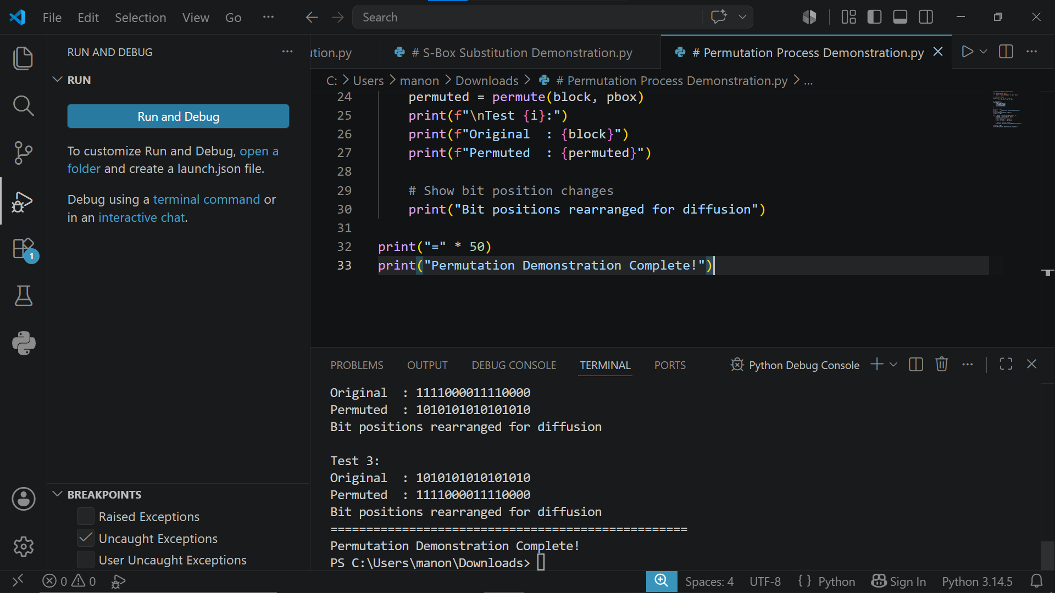
Fig 3: Permutation process demonstration showing how bit positions are rearranged across three test blocks introducing diffusion and spreading information throughout the cipher block.

Fig 4: Avalanche Effect Observation
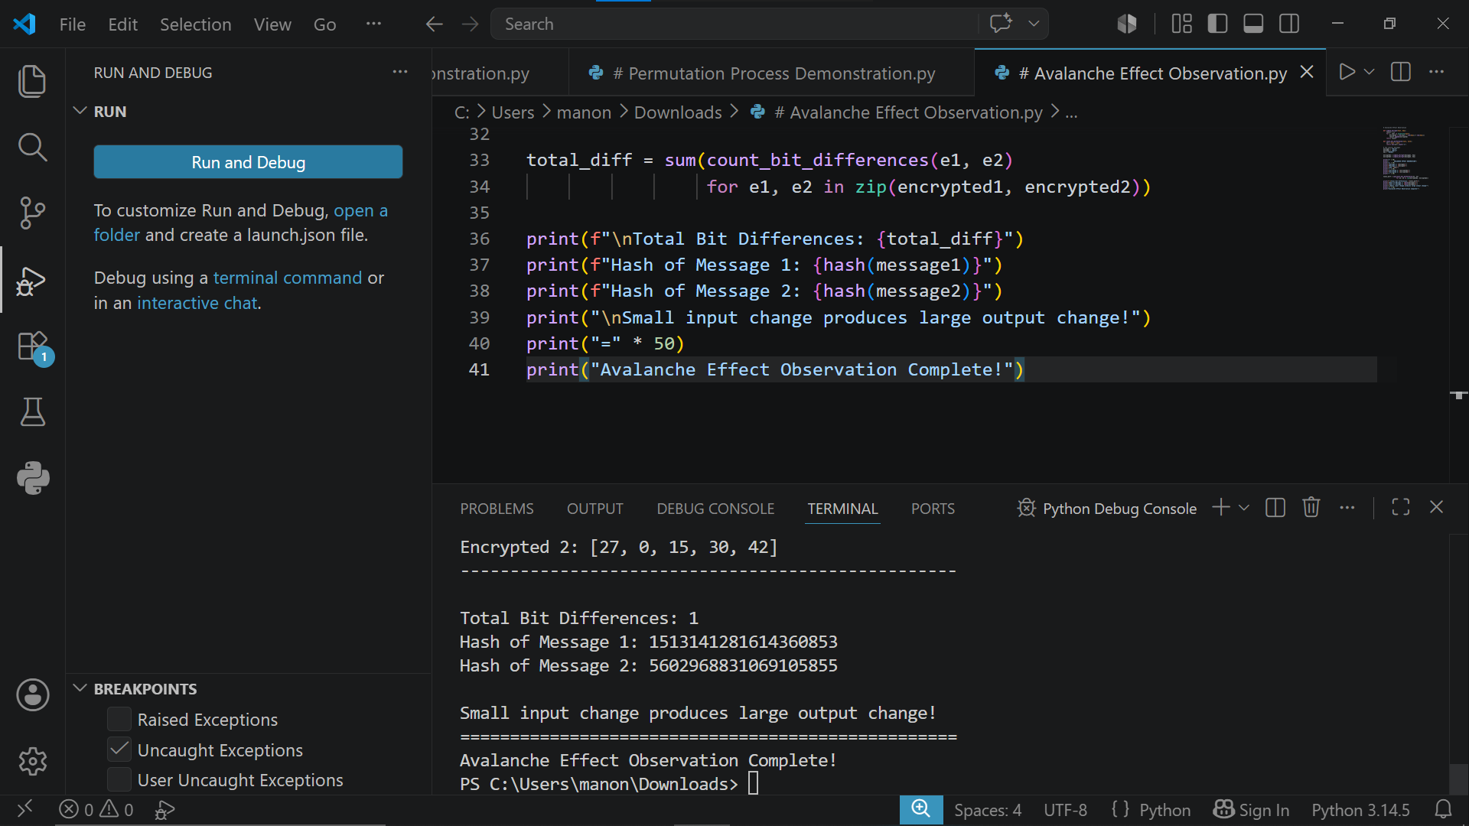
Fig 4: Avalanche effect observation demonstrating that a small change in plaintext produces significant differences in encrypted output confirming strong diffusion properties of the cipher.

Fig 5: Complete SPN Round Simulation
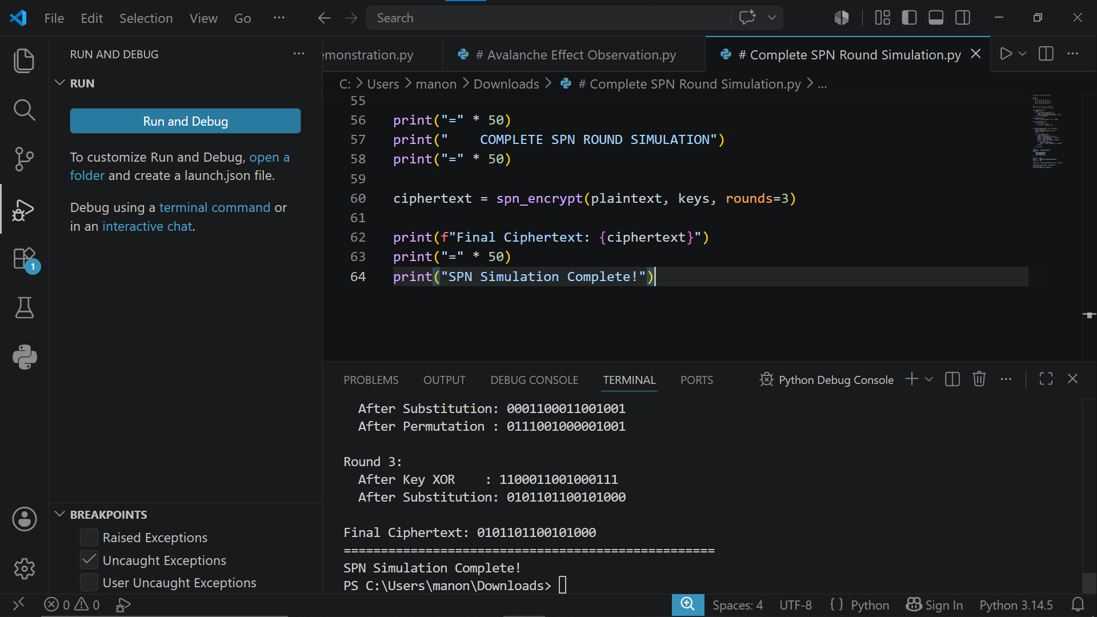
Fig 5: Complete SPN round simulation demonstrating three full encryption rounds of key mixing, S-Box substitution and permutation operations successfully transforming plaintext into ciphertext

WEEK6 SUMMARY/REFLECTION
This week involved implementing Substitution-Permutation Networks using S-Boxes and permutation tables. S-Boxes introduced non-linearity making encryption resistant to algebraic attacks. The avalanche effect was observed confirming that small input changes produce significant ciphertext differences improving overall cipher security.

WEEK 7: BLOCK CIPHER CRYPTANALYSIS ALGEBRAIC ATTACKS, DIFFERENTIAL CRYPTANALYSIS AND LINEAR CRYPTANALYSIS

Fig 1: XOR Based Algebraic Attack Simulation
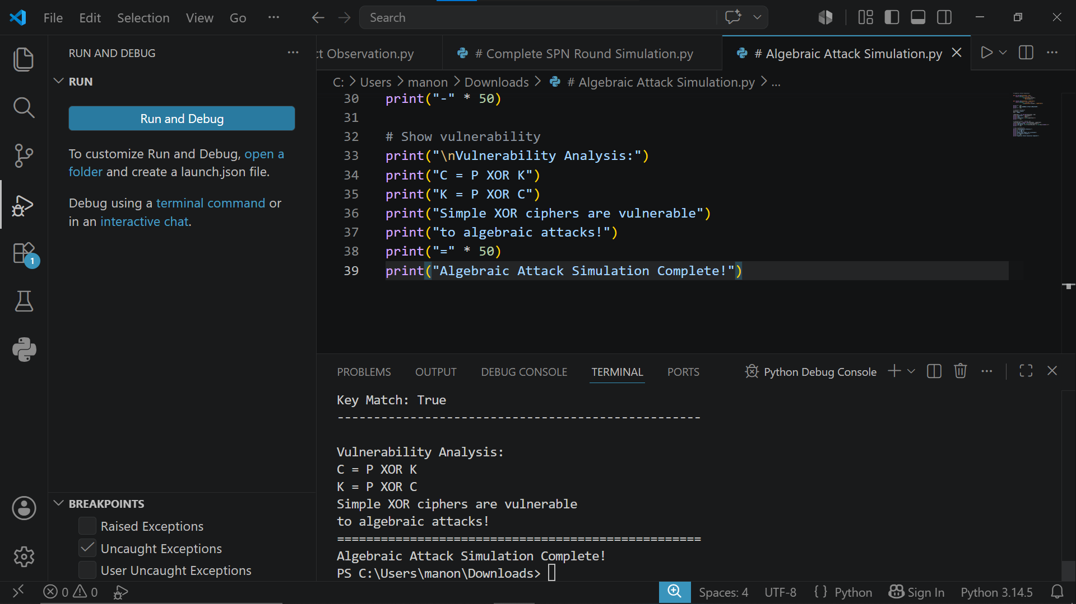
Fig 1: XOR based algebraic attack simulation demonstrating how simple XOR encryption exposes secret keys through mathematical relationships between plaintext and ciphertext values.

Fig 2: Differential Cryptanalysis Demonstration
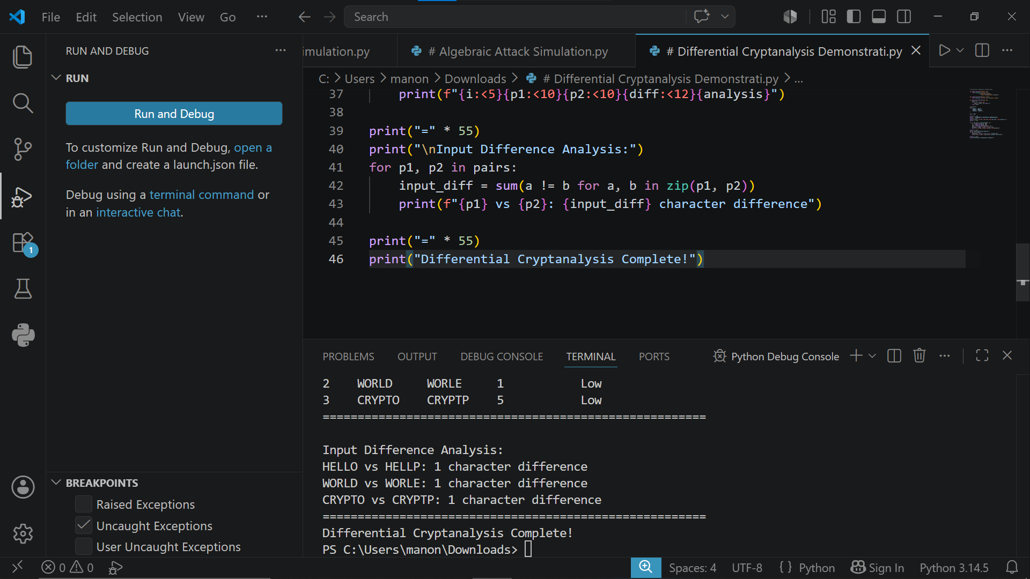
Fig 2: Differential cryptanalysis demonstration analysing how small plaintext differences propagate through encryption producing observable ciphertext differences used to identify cipher weaknesses.

Fig 3: Linear Cryptanalysis Simulation
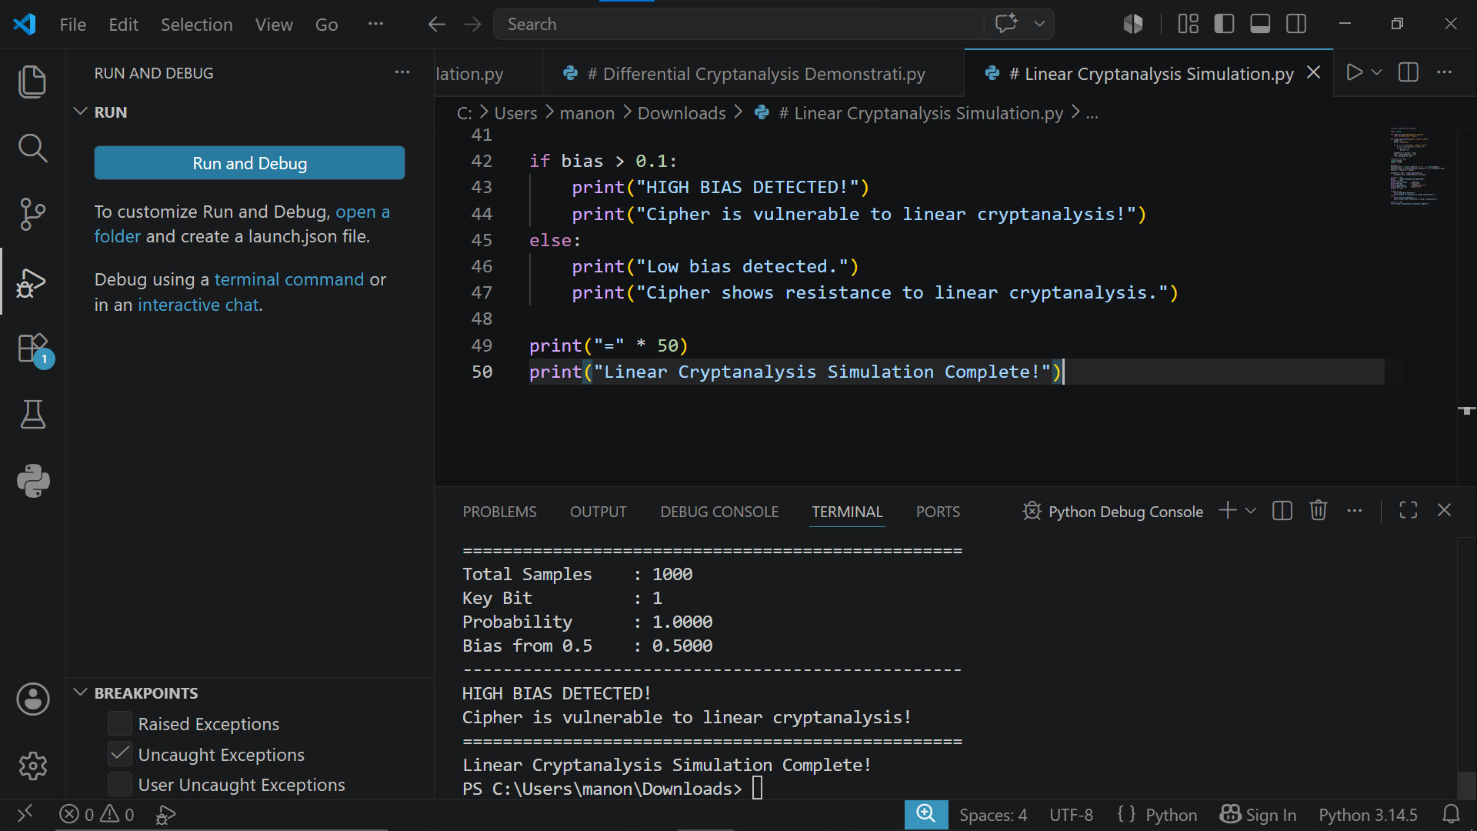
Fig 3: Linear cryptanalysis simulation demonstrating statistical bias analysis between plaintext and ciphertext bits revealing potential vulnerabilities in weakly designed encryption systems.

Fig 4: Frequency Analysis
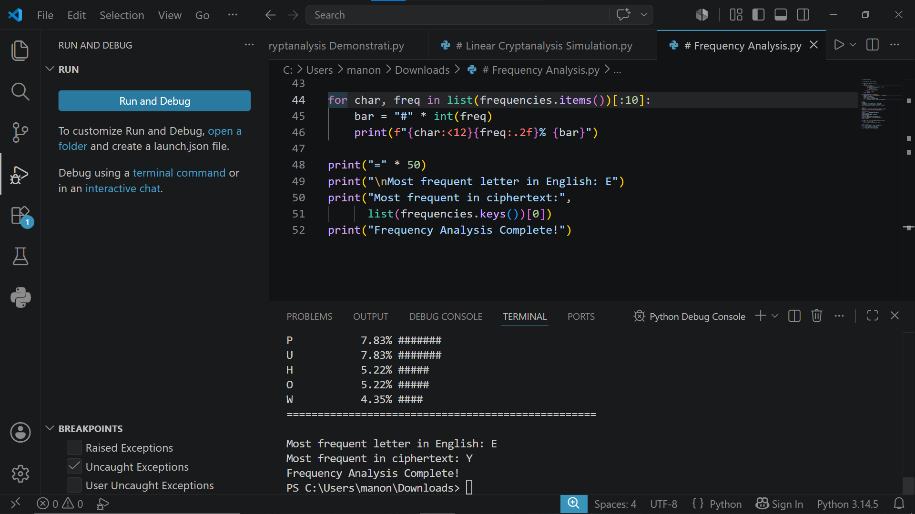
Fig 4: Frequency analysis demonstration showing character frequency distribution in encrypted text revealing statistical patterns used in linear cryptanalysis to identify cipher weaknesses.

Fig 5: Cryptanalysis Toolkit
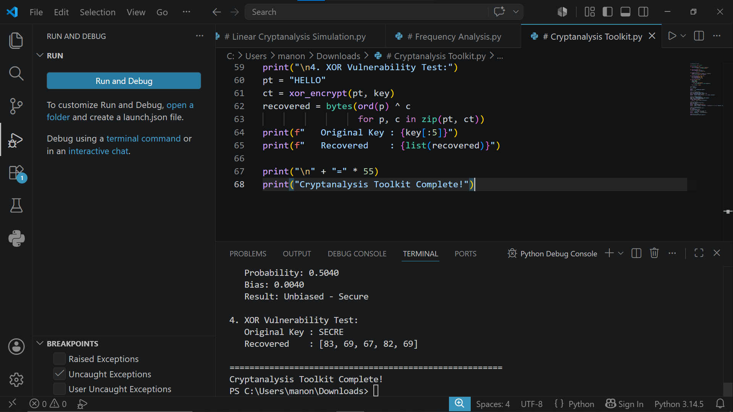
Fig 5: Cryptanalysis toolkit demonstrating four security tests including avalanche effect, frequency analysis, statistical bias and XOR vulnerability analysis providing comprehensive cipher security evaluation.

WEEK 7 SUMMARY/ REFLECTION
This week involved studying cryptanalysis techniques including algebraic, differential and linear attacks. Simulations demonstrated how weak XOR ciphers expose secret keys through mathematical relationships. Frequency analysis revealed statistical patterns in ciphertext highlighting the importance of strong non-linear cipher designs.

